ONEWAY SA BY WOKE
/STATISTICS DESCRIPTIVES HOMOGENEITY WELCH
/PLOT MEANS
/MISSING ANALYSIS.

Oneway

Notes
Output Created |  | 05-May-2019 23:46:57
Comments
Input | Active Dataset | DataSet0
Input | Filter | <none>
Input | Weight | <none>
Input | Split File | <none>
Input | N of Rows in Working Data File | 30
Missing Value Handling | Definition of Missing | User-defined missing values are treated as missing.
Missing Value Handling | Cases Used | Statistics for each analysis are based on cases with no missing data for any variable in the analysis.
Syntax |  | ONEWAY SA BY WOKE  /STATISTICS DESCRIPTIVES HOMOGENEITY WELCH  /PLOT MEANS  /MISSING ANALYSIS.
Resources | Processor Time | 00 00:00:00.156
Resources | Elapsed Time | 00 00:00:00.165

[DataSet0]

Descriptives
 | N | Mean | Std. Deviation | Std. Error
Between 1-4 hours | 5 | 25.8000 | 16.11521 | 7.20694
Between 4-6 hours | 9 | 30.3333 | 21.99432 | 7.33144
Between than 6-8 hours | 3 | 37.0000 | 21.28380 | 12.28821
More than 8 hours | 13 | 21.9231 | 11.45616 | 3.17737
Total | 30 | 26.6000 | 16.74062 | 3.05640

Descriptives
 | 95% Confidence Interval for Mean |  | Minimum | Maximum
 | Lower Bound | Upper Bound | Minimum | Maximum
Between 1-4 hours | 5.7903 | 45.8097 | 5.00 | 50.00
Between 4-6 hours | 13.4270 | 47.2397 | 6.00 | 67.00
Between than 6-8 hours | -15.8719 | 89.8719 | 18.00 | 60.00
More than 8 hours | 15.0002 | 28.8460 | 14.00 | 58.00
Total | 20.3490 | 32.8510 | 5.00 | 67.00

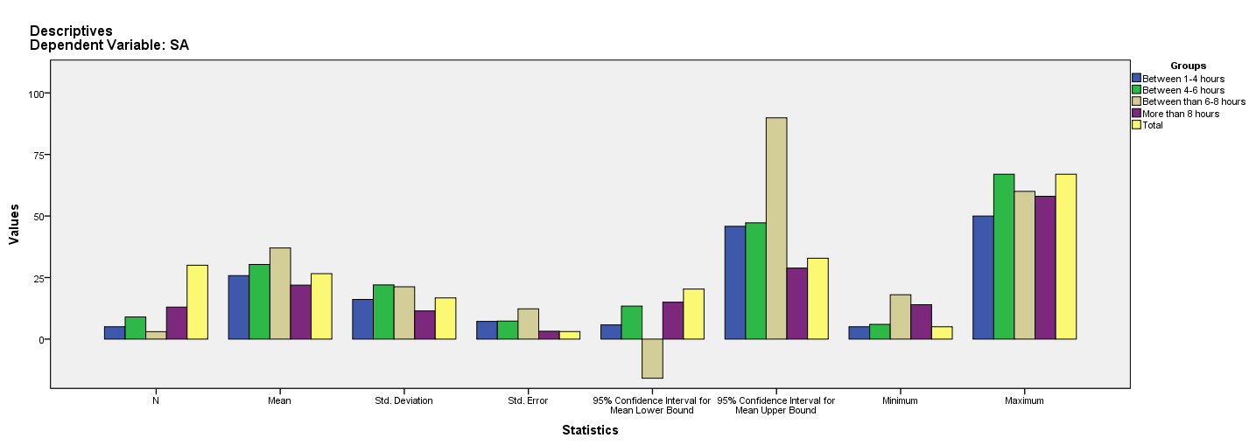

Test of Homogeneity of Variances
SA
Levene Statistic | df1 | df2 | Sig.
2.336 | 3 | 26 | .097

ANOVA
SA
 | Sum of Squares | df | Mean Square | F | Sig.
Between Groups | 737.477 | 3 | 245.826 | .865 | .472
Within Groups | 7389.723 | 26 | 284.220
Total | 8127.200 | 29

Robust Tests of Equality of Means
SA
 | Statisticª | df1 | df2 | Sig.
Welch | .653 | 3 | 6.711 | .607
a. Asymptotically F distributed.

Means Plots

